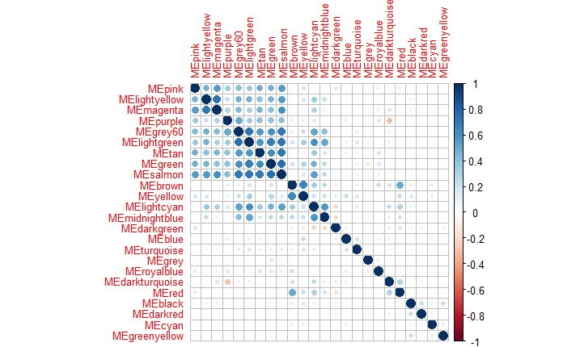

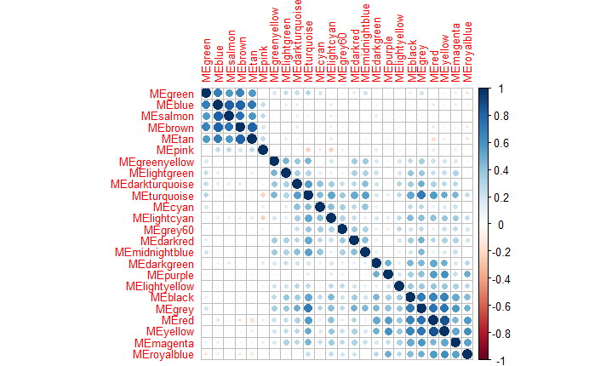

Supplementary Figure 2 – Plot of eigengene correlations for WGCNA modules for a) 2000 and b) 2015 data sets. The correlation method is Spearman and the plot is clustered hierarchically.